# Introduction

The goal of this assignment is to equip the robotic arm with an automatic screwdriver and program it to screw and unscrew screws of a PC case. The robotic arm used in this project is Universal Robot UR3 and the automatic screwdriver used is AD150R04-A.

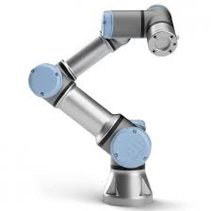

Figure: Universal Robot UR3

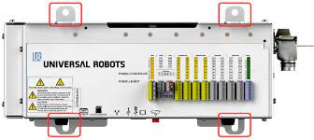

Figure: Controller box

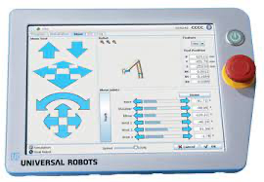

Figure: Teach Pendant

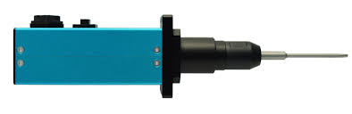

Figure: HANTAS AD driver robotic spindle

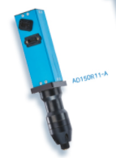

Figure: HANTAS AD150R04-A

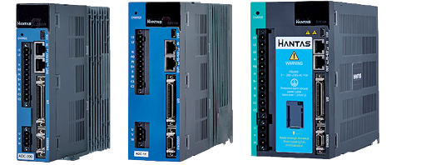

Figure: HANTAS AD 400 Controller

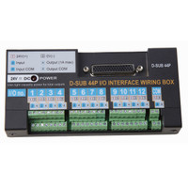

Figure: D-54B 44P I/O interface wiring box

The Universal Robot UR3 belongs to the CB3 family. It is a cobot that is amazing in repeatability, accuracy and dependability that make them a valuable addition to any production facility. Universal robots are trusted by industrial companies to automate standard processes with basic applications such as machine tending, screw driving and palletization. It is suitable for businesses with the need to automate existing core business processes. The UR3 is a small but powerful cobot with a payload of 3kg and reach radius of 500mm. With 360 degree rotation on all wrist joints and infinite rotation on the end joint, this table-top cobot handles high precision tasks and light assembly tasks with ease. This robot aids human labour in tasks such as dangerous machinery, multiple processes and specialized products. These kinds of tasks pose no deterrence to our line of collaborative robots.

The Universal Robot UR3 comes with a teach pendant and a controller box. The teach pendant is a 12 inch display which can be used to program the UR3 to do different tasks. It can also be used to control digital I/O, analog I/O and other safety features of the UR3. The controller box contains the I/O ports, USB and Ethernet ports. This controller box allows communication with other devices and PLC through analog I/O, digital I/O and USB. This allows the UR3 to control each connected device using the teach pendant and programs which streamlines the operation process.

HANTAS AD150R04-A is a reliable robotic spindle system engineered for accurate and repeatable torque control. It is optimized for automation lines by improving productivity and reducing labor costs. When used with robots, accurate and difficult to assemble sections can also be assembled. PC or PLC can control torque, speed control and tightening results monitoring by communication. The model I used is one of the many different models in the HANTAS AD Driver catalog. Different models come with different torque output, RPM, weight and drive size. The AD driver comes with Hantas ADC- 400 Torque Angle Controller and a D-54B 44P I/O interface wiring box. The controller communicates the spindle with other devices such as PLC, digital or analog input /output or PC through serial communication or USB. The I/O interface wiring box allows digital input and output to control different parameters of the spindle. It uses a 24V DC supply to send digital signals. It’s digital input is NPN type.

|  |  |  |  |  |
| --- | --- | --- | --- | --- |
| Model | Torque (Kfg.cm) | RPM | Weight (Kg) | Drive Size |
| AD150R04 | 8 ~ 60 | 100 - 1200 | 1.30 | Hex ¼” |

## Step 1 Metal handle to hold the tool

* Design the metal bracket in SolidWork to hold the AD driver onto the robotic arm ( Credits to [Lee Chuzen](mailto:chuzen.lee@vitrox.com))
  + 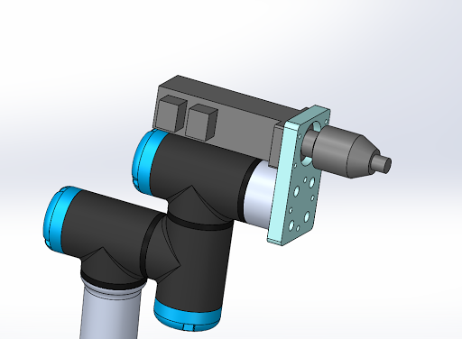
  + 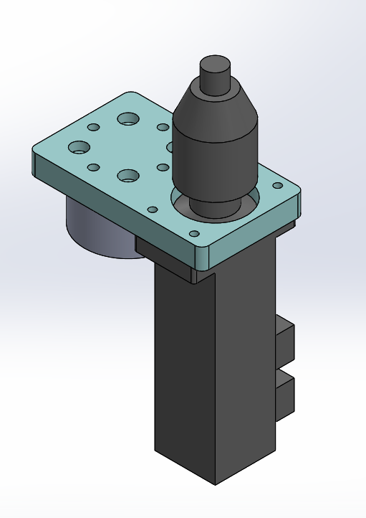
  + 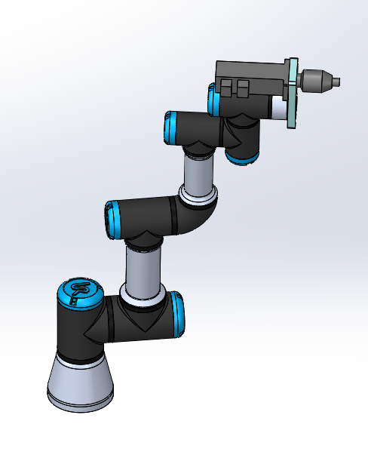

## Step 2 Cables and I/O Management

* Cut the correct cable lengths for each connection and add ferrule to them.
* Connect the digital outputs from the UR controller box to the digital inputs of the controller.
  + This part is tricky because the type of circuits are different for both. For the UR robot, it uses PNP or sinking input. For the I/O interface wiring box, it uses NPN or sinking output. This means the digital output from the I/O interface box cannot be directly connected to the digital input of the UR controller box.

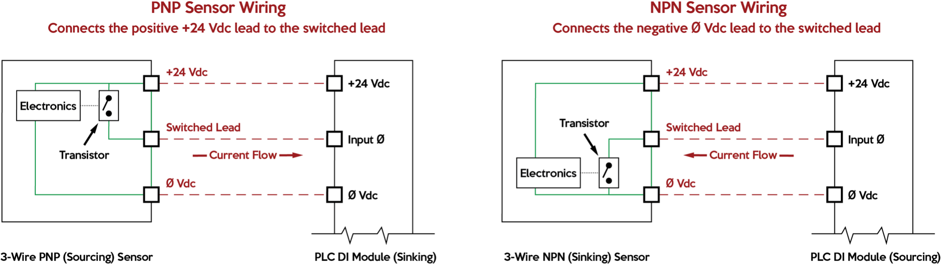Figure: PNP and NPN

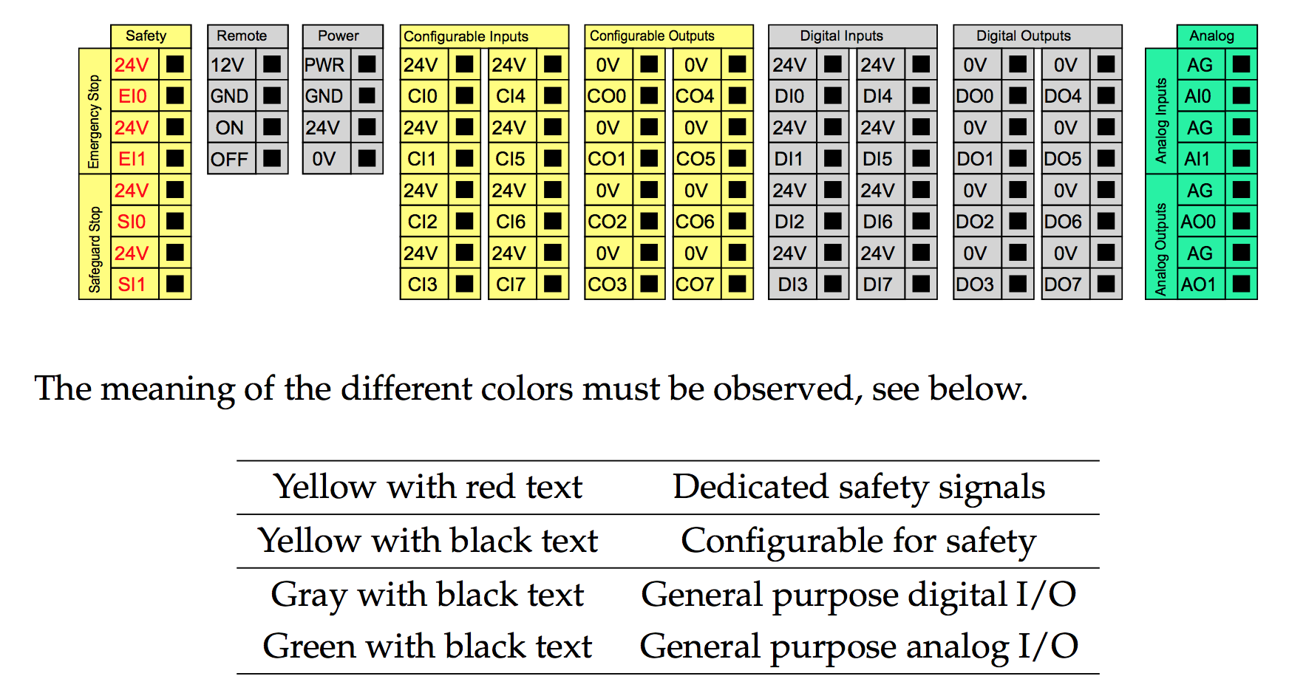

Figure: I/O of UR3 Controller Box

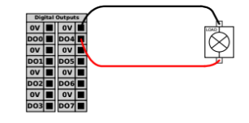

Figure: Load controlled by a digital output

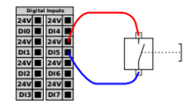

Figure: Digital Input from a button/ relay

|  |  |  |  |  |
| --- | --- | --- | --- | --- |
| D-Sub 44P | | | | UR Controller Box |
| I/O | Port | Input/ Output | Function | Port |
| 1 | 2 | Input | PRESET SELECT 1 | DO 0 |
| 4 | Output | TORQUE UP | DI 1 |
| 2 | 2 | Input | PRESET SELECT 2 | DO 1 |
| 4 | Output | FASTENING OK | DI 2 |
| 3 | 2 | Input | PRESET SELECT 3 | DO 2 |
| 4 | Output | READY | DI 3 |
| 4 | 2 | Input | START | DO 3 |
| 4 | Output | MOTOR RUN | DI 4 |
| 5 | 2 | Input | FASTEN/LOOSEN | DO 4 |
| 4 | Output | ALARM | DI 5 |
| 6 | 2 | Input | DRIVER LOCK | DO 5 |
| 4 | Output | F/L STATUS | DI 6 |
| 7 | 2 | Input | MULTI SEQUENCE | DO 6 |
| 4 | Output | COUNT COMPLETE | DI 7 |
| 8 | 2 | Input | RESET | DO 7 |

Table: Connections and their functions

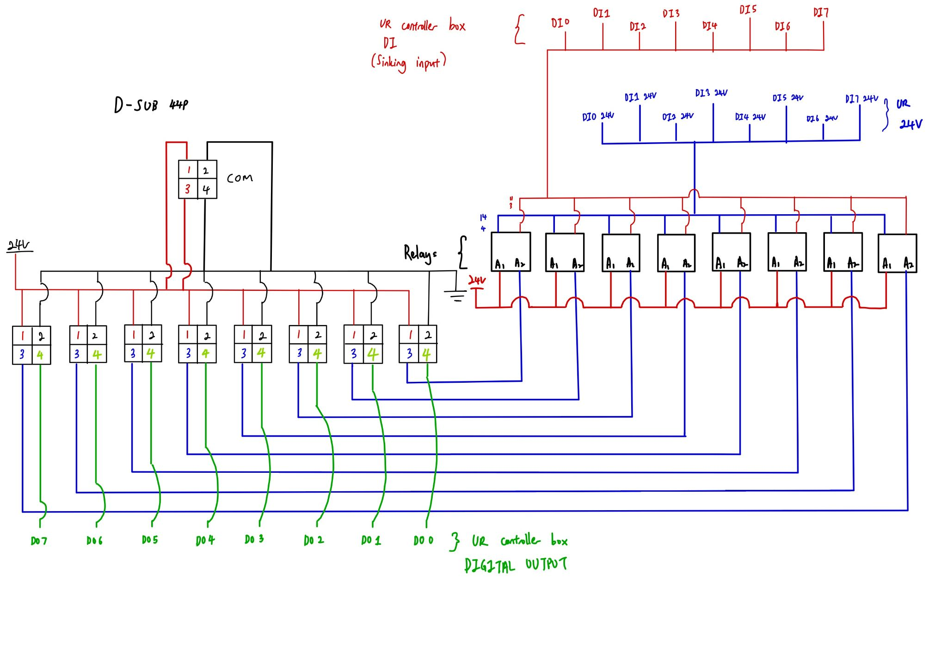  
Figure: Circuit schematic of connection between D-Sub 44P and UR controller box

* + Thus, to make the connection match, a relay has to be used. The digital output from the I/O interface wiring box will trigger the relay to complete the circuit for the UR digital input. The digital input of the UR will receive an input when the circuit completes.
* Connect the digital inputs from the UR controller box to the digital outputs of the controller.
* Cable management

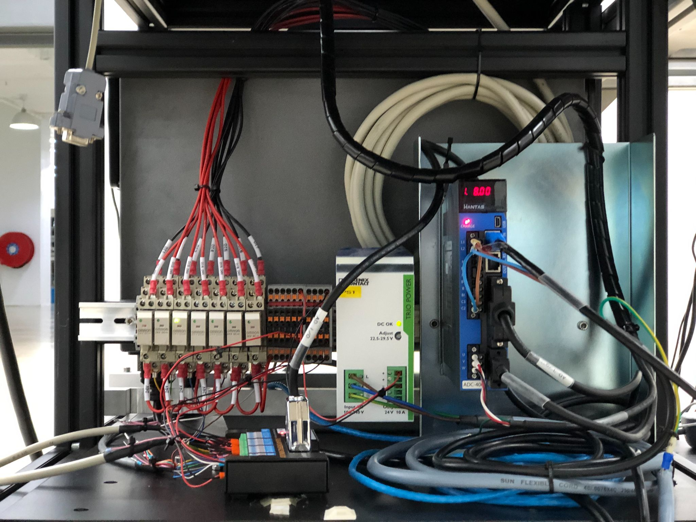

Figure: I/O wiring box, Relays, Terminal Blocks, Power Supply and AD400 Controller

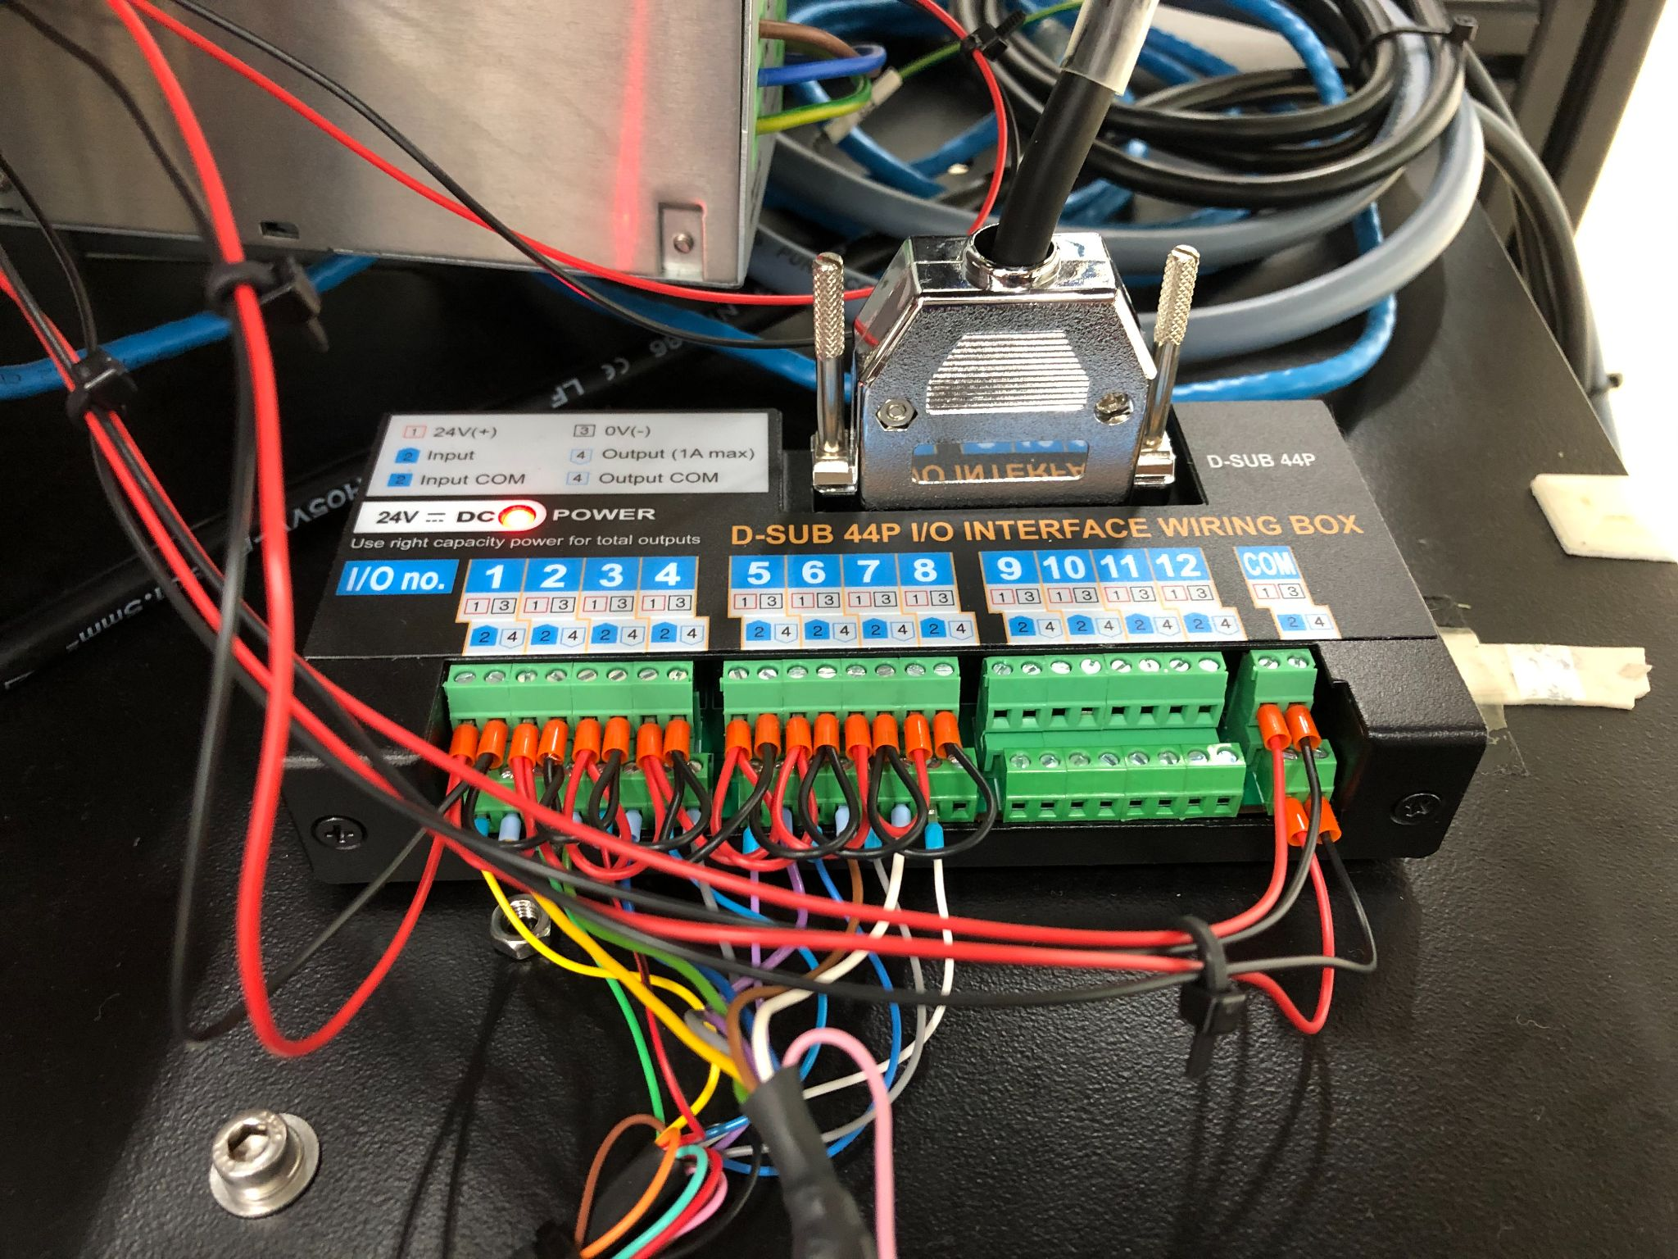

Figure: D-SUB 44P I/O Interface wiring box

## Step 3 Program the UR3

* Set Tool Centre Point (TCP), Centre of Gravity (COG) and Payload.

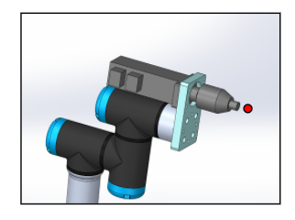

Figure: Tool Centre Point

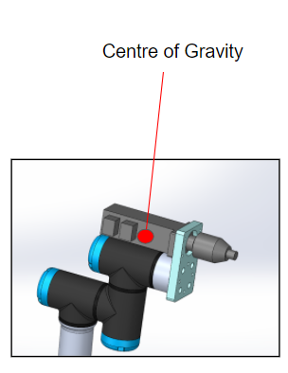

Figure: Centre of Gravity

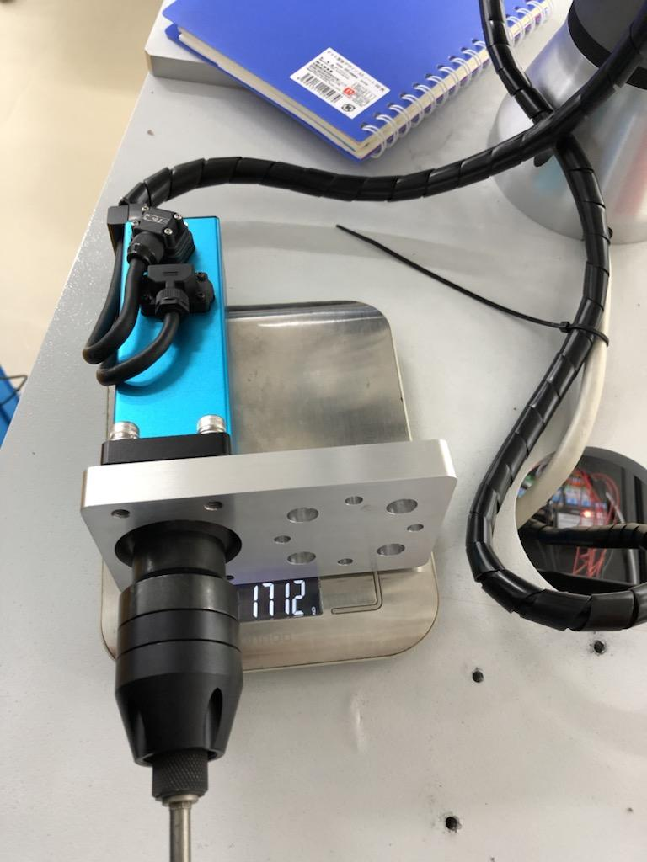

Figure: Mass of Tool (Payload)

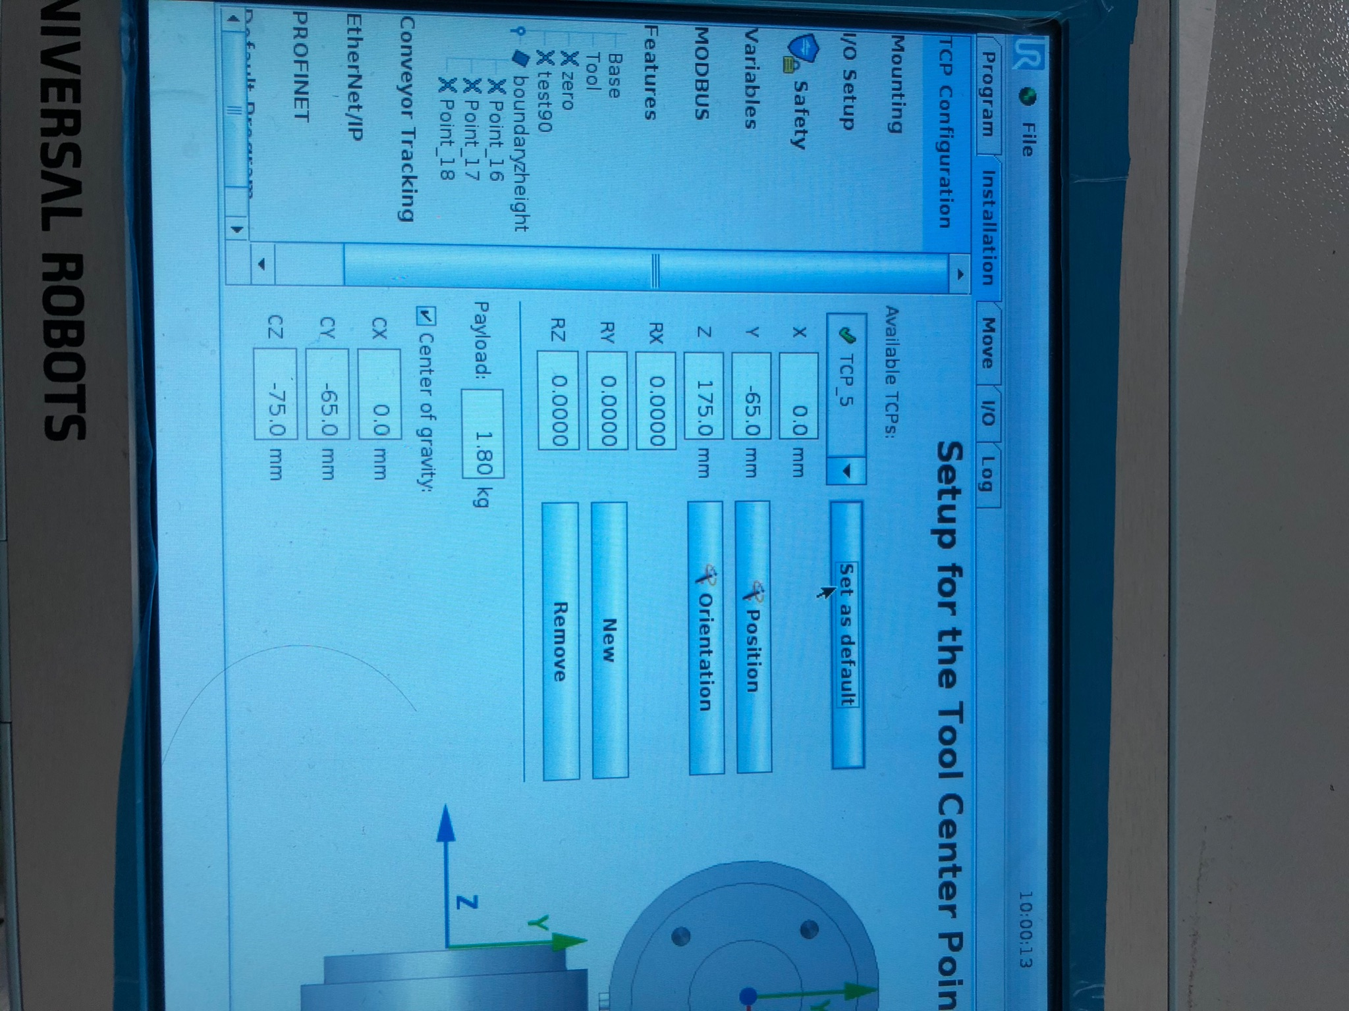

* Program the robot’s movements and I/O triggers.
  + Every point the robot arm stops has to be set.
  + When the screwdriver reaches the screwing/ unscrewing position, the UR controller box will send a digital output to the screwdriver to start fastening/loosening.
  + After screwing/ unscrewing, the UR controller box will send another digital output signal to stop the screwdriver.
  + Each waypoint has to be very precise. Any inaccuracy will cause failures during the operation.

### **Program 1** Screw 4 screws into PC case

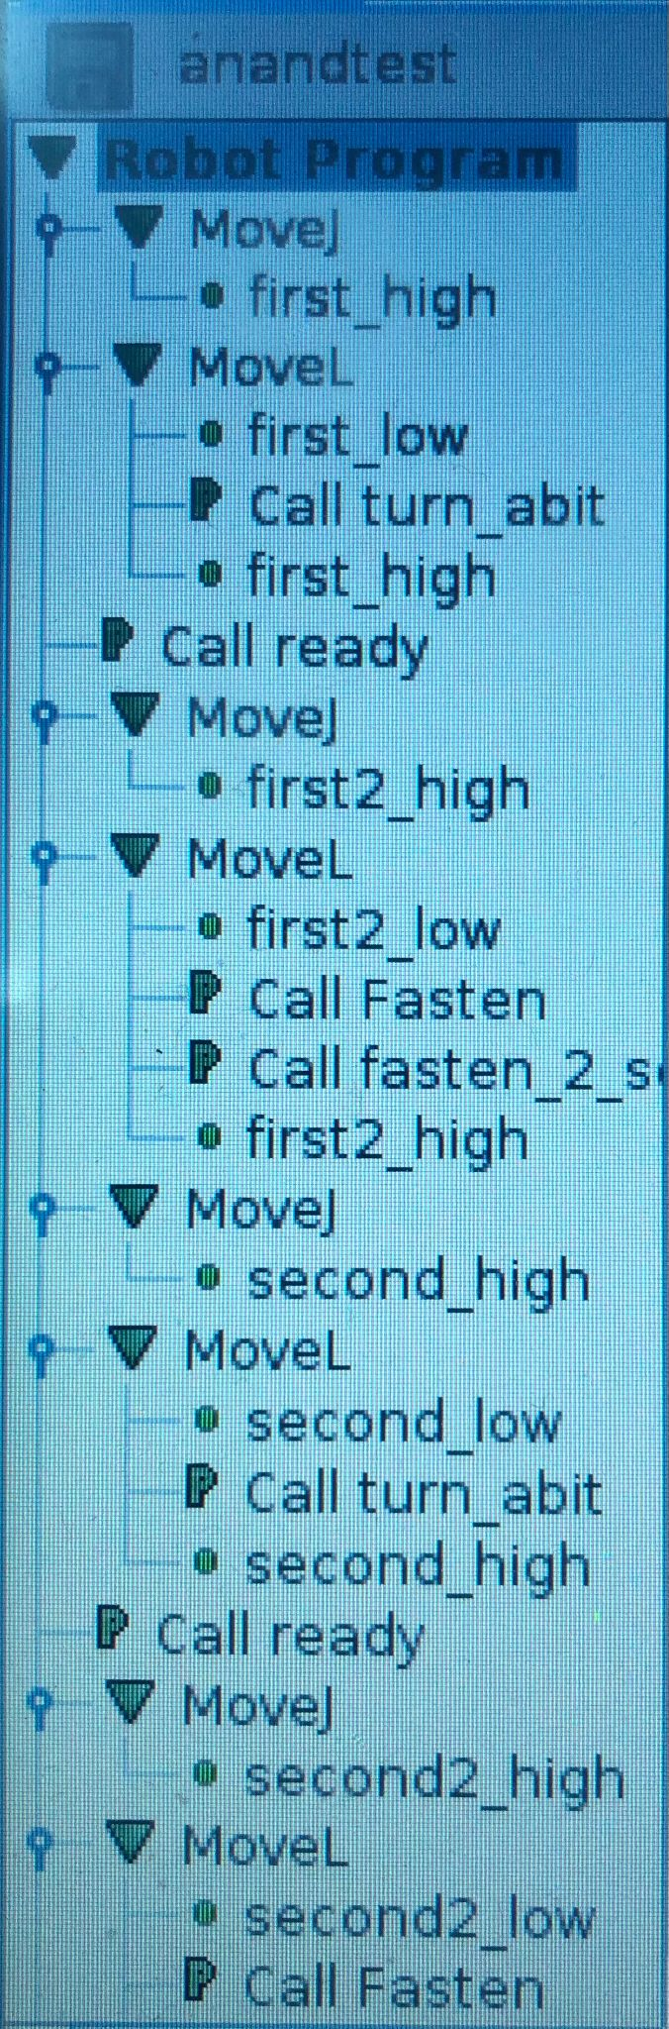

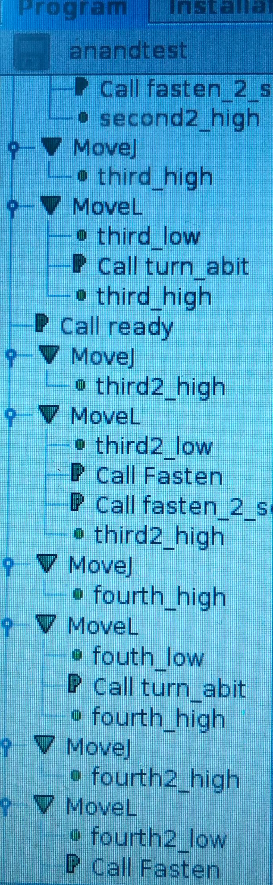

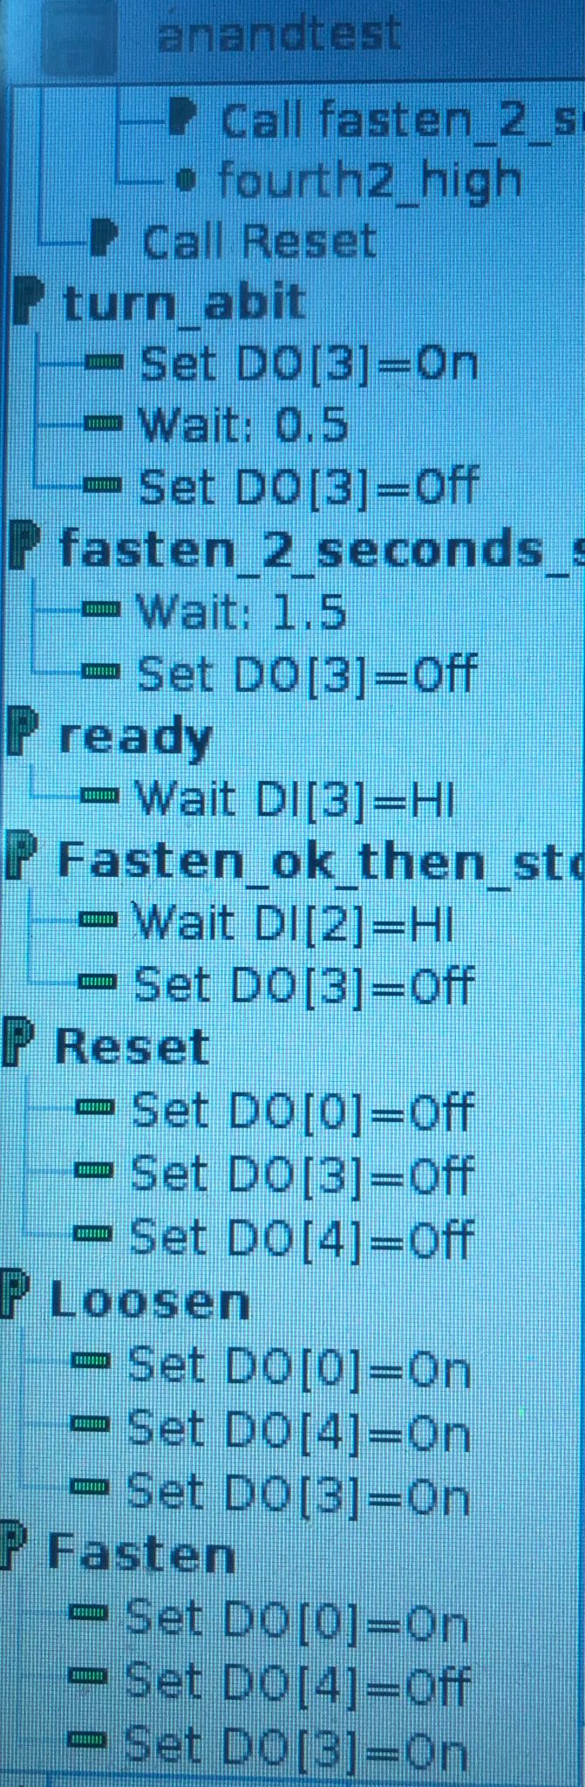

[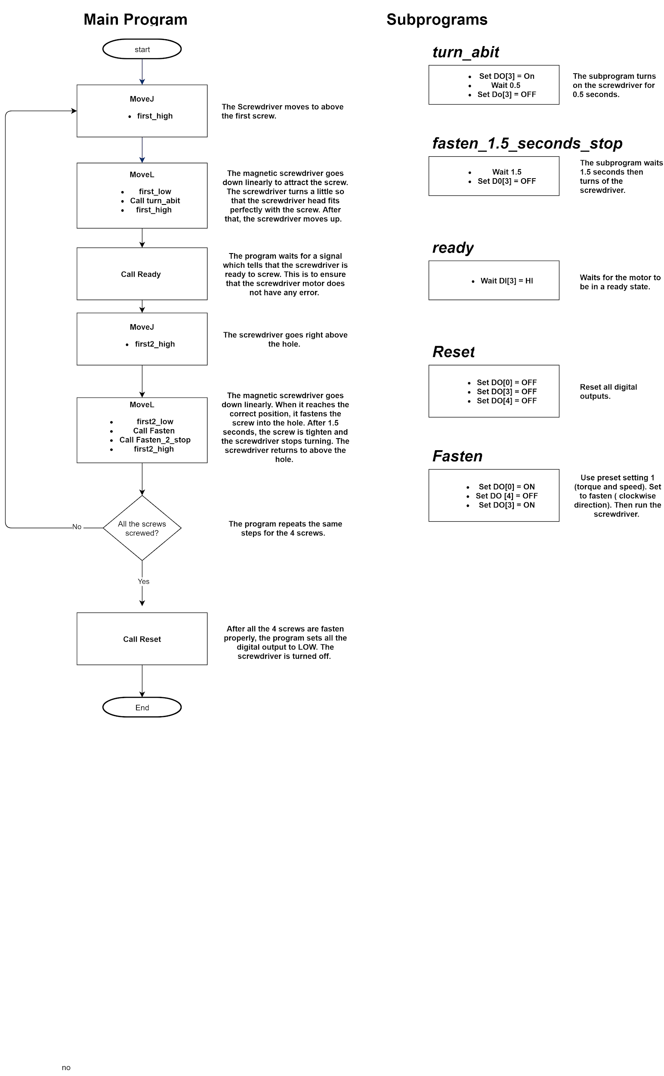](https://app.diagrams.net/?page-id=6a731a19-8d31-9384-78a2-239565b7b9f0&scale=auto#G1qPu5g98dQPA-6TxqIc4CqH6lFRZGEu2k)

Video Link: https://drive.google.com/file/d/1YNFeEYNI0oMs84ExI1ozXkusFjjRKFnT/view?usp=sharing

**Program 2** Unscrew 4 screws

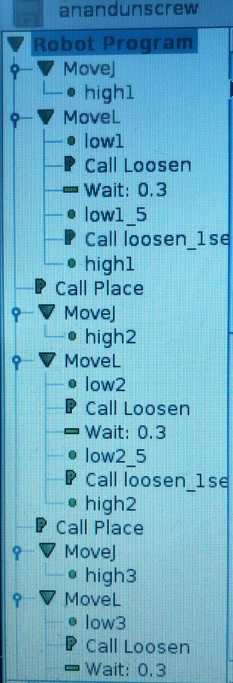

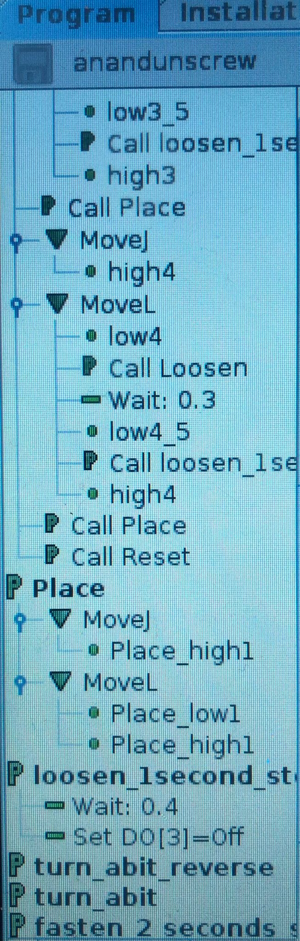

[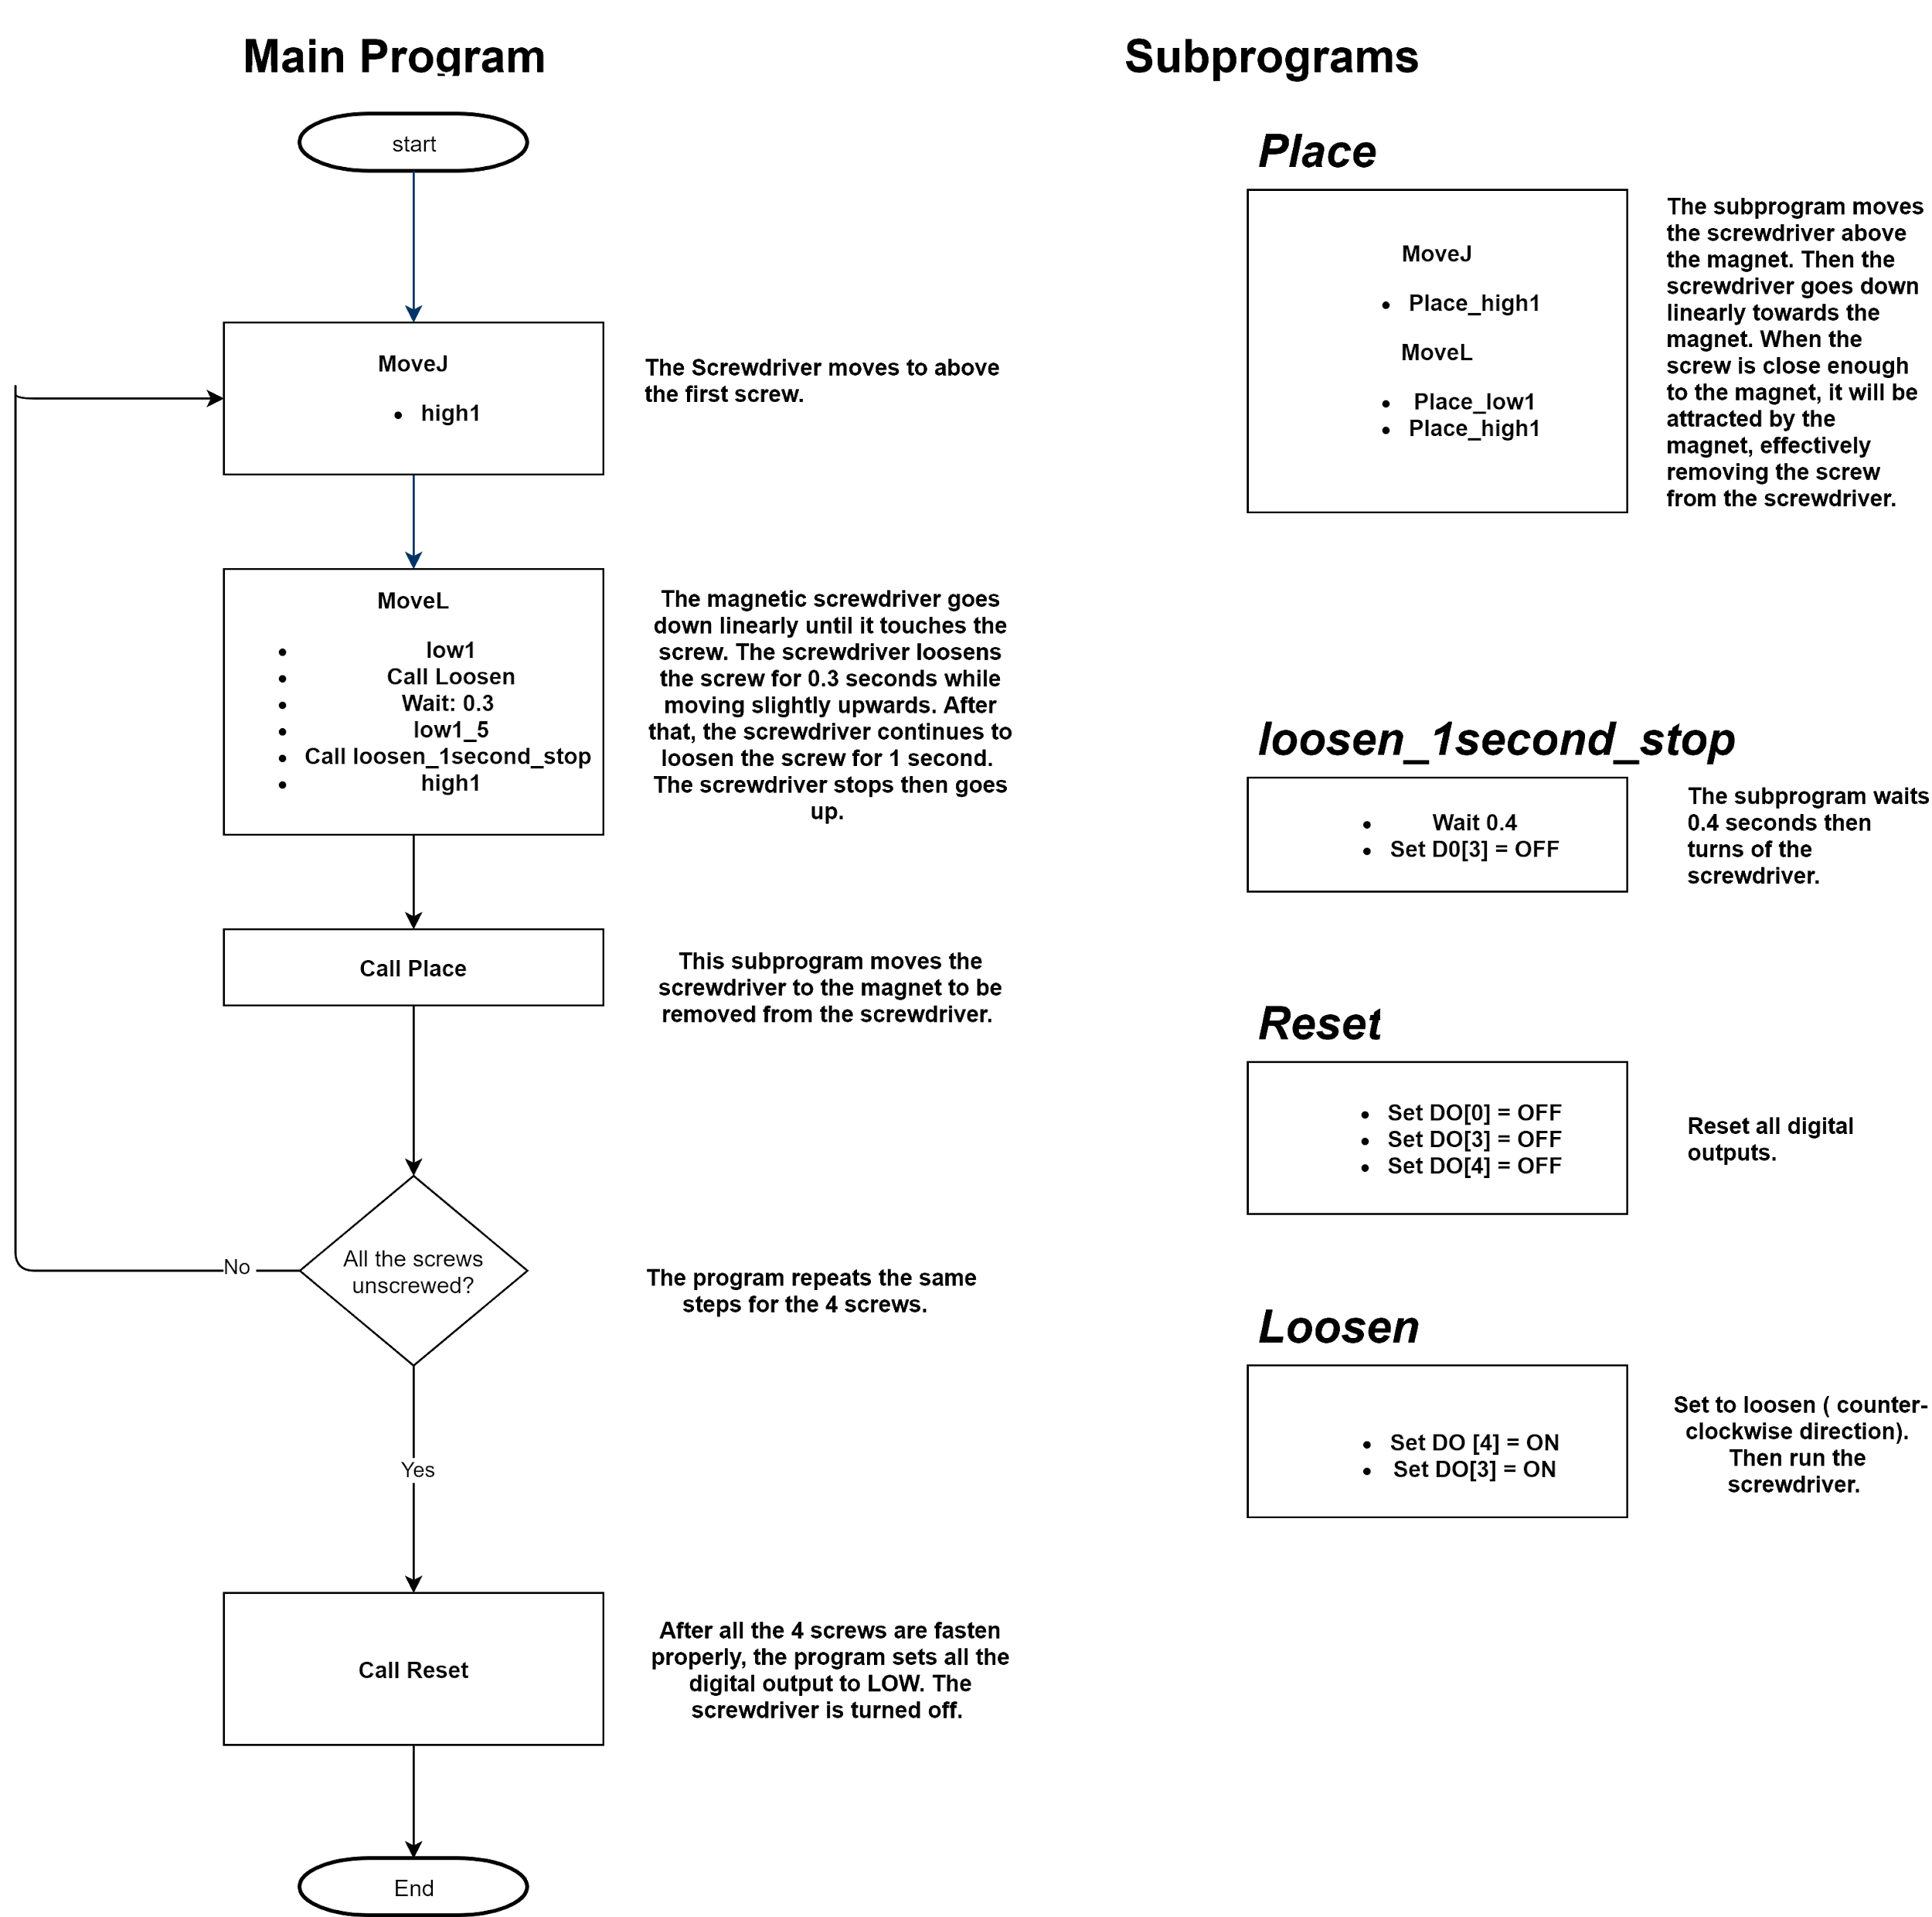](https://app.diagrams.net/?page-id=07x2rM5bFDmbLVZhOYU2&scale=auto#G1X5HwX4-23YDdmdhdPWIFbOZ9_s8OfO9h)

Video Link: <https://drive.google.com/file/d/1hphwxMrRZiLfRagLv42A2y5BSD9cYLZs/view?usp=sharing>

## Pros

1. Accurate in the robot’s movement
2. Variable speed control, can achieve very high speeds
3. Save time during operation and manufacturing
4. Good at repeatable tasks
5. A lot of programmable functions which can be customized for different operation needs
6. Great safety features by Universal Robot

## Cons

1. High cost of robot and automatic spindle
2. Optimizes and automates some specific operation processes but not all
3. Screwdriving requires a lot of factors to be fine tuned such as position of the robot arm, wobble of the screw bit, screw pick up place
4. UR3 is a smaller cobot which means it’s range is also limited

## Application

Cobots are low cost industrial robots that are safe to operate in close proximity to humans, which traditional industrial robots lack. They are also more flexible and compact without having to operate within safety cages or fencing directly alongside people. Cobots have different applications, but they share the same goal which is improved production. These robots aim to improve the efficiency and safety of many industries by assuming dull, dirty and dangerous jobs.

Collaborative robot applications include assembly, dispensing, finishing, machine tending, material handling, welding, material removal, quality inspections, and more. We can classify these tasks into 3 common classes.

### Material Handling

Material handling is one of the most dangerous jobs in manufacturing. Materials such as metal, plastic and other substances can pose a great risk to human workers. Moreover, most of these tasks are repetitive, which can give rise to repetitive muscle strain injury. Other than that, heavy materials can easily be lifted and transported across factory floors using cobots on mobile robot platforms.

### Assembly and quality assurance

Cobots are designed to work collaboratively with human employees and relieve them from difficult and tedious assembly jobs. This includes welding small pieces together, drilling screws and other similar assembly tasks. Another benefit of cobots is they can perform the same task the same way, every time, without growing tired or suffering any loss in performance. For an example, cobots can place a camera in the same location for as many measurements and positions on as many work pieces as needed, without recalibration.

### Material Removal

Material removal by robots is needed for any process that involves filling molds. These small robots can assess the molded piece and take care of trimming any excess metal or plastic without damaging the part or injuring human workers. Cobots can be fitted with dispensing tools and hardware that can be used to add glue and other adhesives. Cobots with sanding kit can be used to polish pieces for a bright, smooth finish.